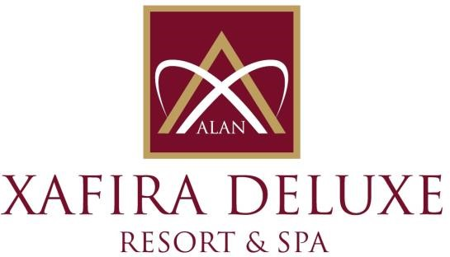
HOTEL FACT SHEET

G E N E R A L I N F O R M A T I O N
HOTEL NAME : ALAN XAFIRA DELUXE RESORT & SPA HOTEL
REGION : TÜRKLER TOURISM CENTER / ALANYA
REGION : 5 * DELUXE HOTEL
ADRESS : TÜRKLER MAHALLESİ, CUMHURİYET BULVARI ALANYA / ANTALYA / TÜRKİYE
TELEPHONE : 00 90 242 537 65 61
FAX : 00 90 242 537 65 62
WEB : www.xafiradeluxeresort.com
E- MAIL : sales@xafiradeluxeresort.com

TO
HOTEL TRANPORTATION :
DISTANCE METHOD DURATION
ANTALYA CITY TRANSFER | 110 km Bus 90 Min.
ANTALYA AIRPORT | 100 km Bus 80 Min.
ALANYA | 20 km Bus 20 Min.
SİDE | 50 km Bus 60 Min.
ACCOMADATION:
TOTAL ROOM : 803 ALL ROOMS ARE WITH:
TOTAL BEDS : 1718 Direct dial Telephone
Müsic System (Satellite)
Standart Room (Land and Sea View) : 640 ( 37m² ) ( 1 french + 1 twin Bed ) LCD TV (Satellite)
Family Room (with folding doors – Land and Sea View) : 155 ( 46-50m² ) ( 2 bed Rooms, 1 Dush-wc ) Baht Room
Handicap-Friendly Rooms (Land View) : 8 ( 34-37m² ) ( 2 Twin Beds ) Mini bar & Safe

SPECIAL FEATURES:
Site Surface | : 45.000m² Inside Suraface :18000m²
Outdoor Pool | : 3.800m² Children Pool: 75m²
Outdoor Relax Pool | : 310m² Aqua Pool : 250m²
 | Children's Aqua Pool : 250m²
Indoor Pool | : 120m² (with heating system ) Only in the winter season
Xafira Main Restaurant | : 3.660m² / 800 Person Indoor – 700 Person Outdoor OPENING TIMES
Ottoman Cuisine A’la Carte Restaurant | : 400m² / 200 Person 19:00 / 21:00 ( PP 5 €uro )
Italian Cuisine A’la Carte Restaurant | : 200m² / 120 Person 19:00 / 21:00 ( PP 5 €uro )
Fish Cuisine A’la Carte Restaurant | : 200m² / 120 Person 19:00 / 21:00 ( PP 5 €uro )
A’la Carte Open Time is
01.06.2024 -15.10.2024
Game Hall | : Billard, Air hokey, Backgammon, Chess, Card games and Stone games
Wellness, Beauty Center / SPA | : Türk Hammam, Sauna, SPA, Special Massages, Beauty center (private management)
Mini club | : 80 m², for Children between 04 -12 years old
Shopping Center | : Jewellery, Mini Market, Hair Dresser, Boutique, Leather Shop, Silver, Souvenir, Photograph…
Ottoman meeting hall (all) | : 1350 m² : Theatre Style 1100 person – Class Style 700 person, Ball Style 750 person
Info Hall 1 | : 108m² : Theatre Style 100 person – U Style 60 person, I Style 40 person
Info Hall 2 | : 70m² : Theatre Style 60 person – U Style 40 person, I Style 30 person
Meeting Room Equipment | : Barcovision, , Flip chart, screen, sound system, microphone… )
Cleaning Service | : Daily room cleaning and room textiles change every 3 days
Beach | : 100 m. Long Sand & Pepple mixed privat beach
SPORT, FUN, HEALTH AND BEAUTY CENTER:
Extra Charged : Free of Charge :
- Billard * Daily Activities (special games) * Animation Shows
- Cafe & Video Games * Turkish bath, Sauna, Steam Bath, Fitness Center
- Masagge & Peeling -Foam, * Table tennis, Dart, Beach Volleyball, Boccia
- Thai-Bali-Shiatsu-Massages * Step, Aerobic, Gymnastics, Water-Gym
- Beauty Center * Hair Dresser * Skin Care * Aquapark
- Water Sports (Parachute, Boat, Cano, Wind Surf) * Mini Club between 4-12 years old children. Mini Disco
GUEST SERVICE:
Extra Charged : Free of Charge :
- Doctor * Safe in Room
- Rent a Car and Jeep, Motocycles * Animation Shows
- Shopping Center * Wireless (Only in Lobby) * Exchange
- Airport Transfer * Mattress and Umbrellas at the Beach and Pool
- Room Service, Laundry * Beach Towel
- Telephone and Fax Service * Animation Shows
- Massage and SPA Service
USE FULL INFORMATION:
*** Use full Credit Cards : Visa & Master Card
*** Languages : Turkish is the official language. German, English and Russian are spoken.
*** PETS ARE NOT ALLOWED.

